**ShinyApp Document for WOSU**

**October 2019**

Shinyapp is a free server maintained by RStudio. It is free, easy to use, secure and scalable. This app can help the WOSU management track and extract useful and relevant business insights:

1. Donor demography
2. Donor counts in cities
3. Overall Yearly retention rate
4. Overall Yearly gender distribution
5. Overall Yearly spread -All states
6. Overall Yearly spread – All states- excluding Ohio
7. Potential gift sources
8. Network visualization of Cities and Gift Sources.
9. Donation metrics
10. Donor Percentage by Year
11. Donors- Original Gift has Premium
12. Donors- Solicitation Methods
13. Donors – Original Gift Source
14. Organizational Donors

Steps to use Shiny app

1. Type in shinyapps.io in browser.
2. Log into Shinyapps.io [ userid -wosu.shiny.appr@gmail.com, password – wosu#897]
3. You will see the following page:

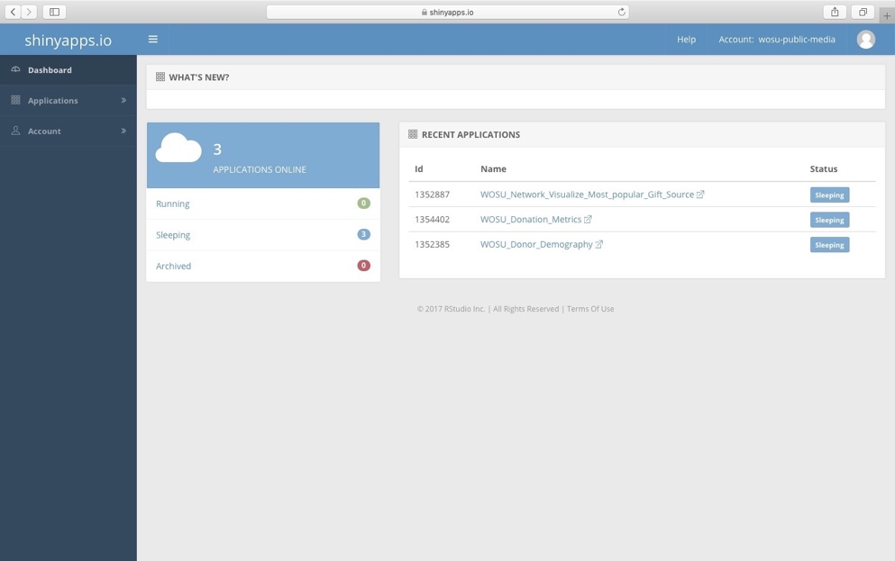

1. There are 3 apps under ‘RECENT APPLICATIONS’ pane.
2. Click on the URL: WOSU_Network_Visualize_Most_popular_Gift_Source under ‘Name’.
3. You will see the following page

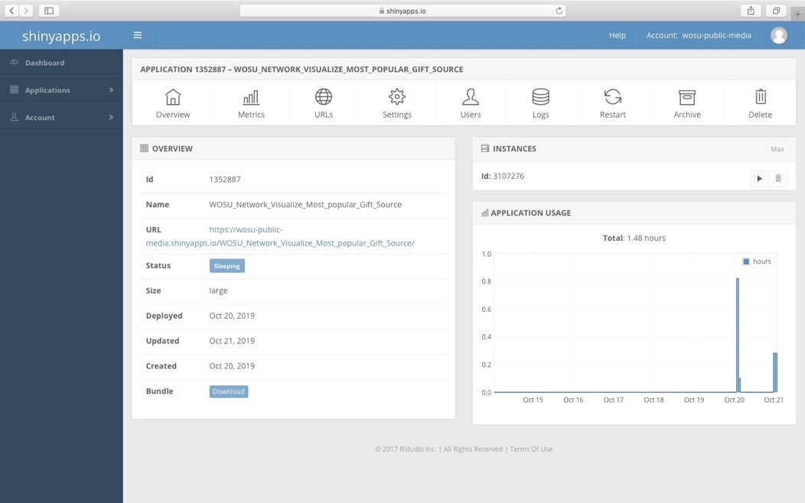

1. Click on the URL found in the OVERVIEW pane and this will show the app .
2. To view the Most Popular Gift Source of First time Donors, use the Slider panel on the left, to select any combination of the 3 variables

- ‘Donations greater than $’

- ‘Donations less than $’

- ‘Gift Year’

and press ‘Click Update Year’.

It will show the Network Visualization of two nodes as Cities and Original Gift source. The nodes at the critical junction has the highest score and is the most popular. The Table below lists the donors for the respective cities and original gift source.

When a particular city name is selected, it will list all the donors from that City along with their account_id, state and Gift amount.

1. Snap shot of Donation Metrics app

1. Snapshot of Donor Demography

